

Report Assignment 1

ELG 5142 Ubiquitous Sensing and Smart City

**Group Number: G_26**

**Team Members:**

**Toka Mostafa,**

**Sawsan Awad,**

**Sondos Mohammed**

Step one: Generating tasks

We need to create 2,000 legitimate tasks for 15,000 users with task properties

* Days: Distribution consistent in [1, 2, 3].
* Hours: 50% (9:00 AM-11:00 AM), 25% (12:00 PM-5:00 PM), 25% (6:00 PM-8:00 AM)
* Minutes: 50% in [20, 40, 60], 30% in [30, 50, 70], 20% in [10, 80, 100].
* Task value: Uniformly distributed in [1,10].

First, we identified the task properties:



Then, we applied the conditions of durations:

After that, we create a folder in the input file called mobility and then create inside it a folder called differentradius then another folder inside it called 50, and we append another column for task value.

Finally, we create mytask_files and csv_files that contain our readings.

Our Results:

.csv file

.txt file

**Step two: Obtain user movement**

We generated user movement events using a stochastic algorithm througth using Dirichlet distribution to select a stochastic path rather than the longest path.



We created an empty list called: I[] to append the values in it, After that we brought random length which is greater than path and less than the longest path and then we got the weight for each path by using np.random.dirichlet ,then we choosed random path by using random.choices.

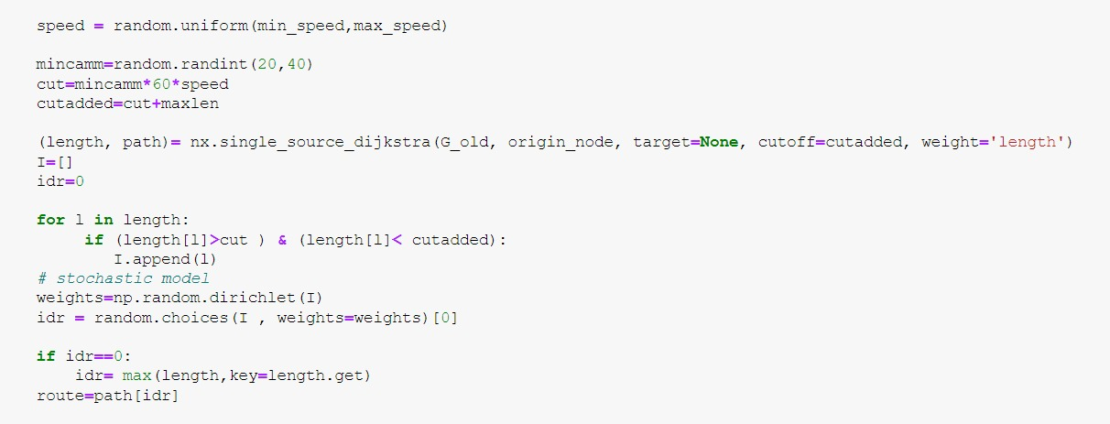

**Output of uniform mobility model (Main ) :**

Editing the setup.txt file by using number of users = 15,000.

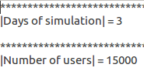

Days= 3

We entered CityName= morlupo

1. **UserMovementsListEvents_0.txt**

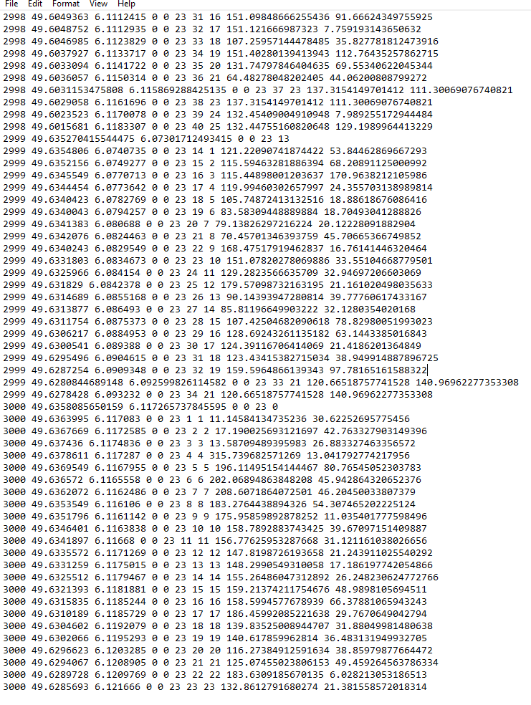

1. **UserMovementsListEvents_1.txt**

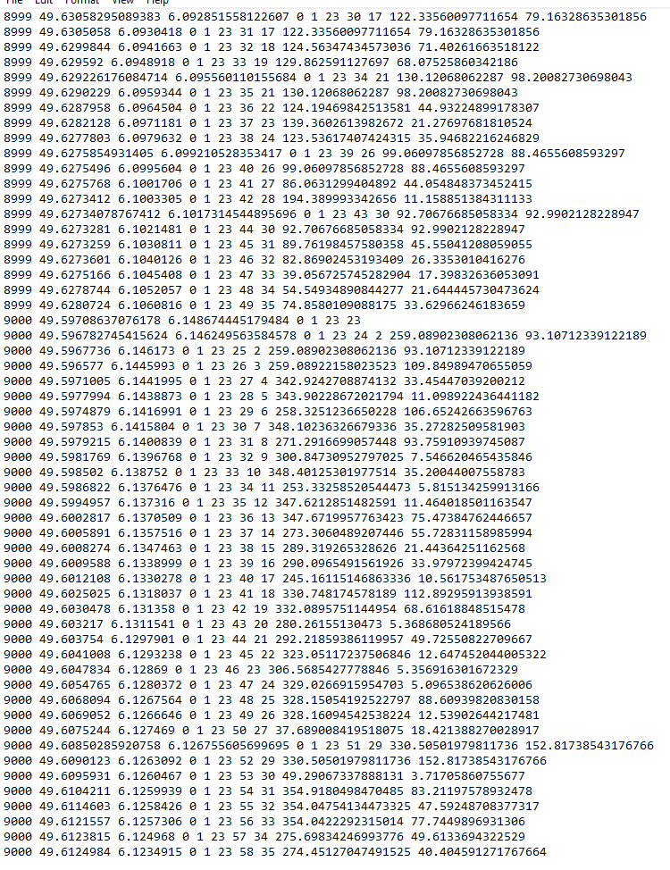

1. **UserMovementsListEvents_** **2.txt**

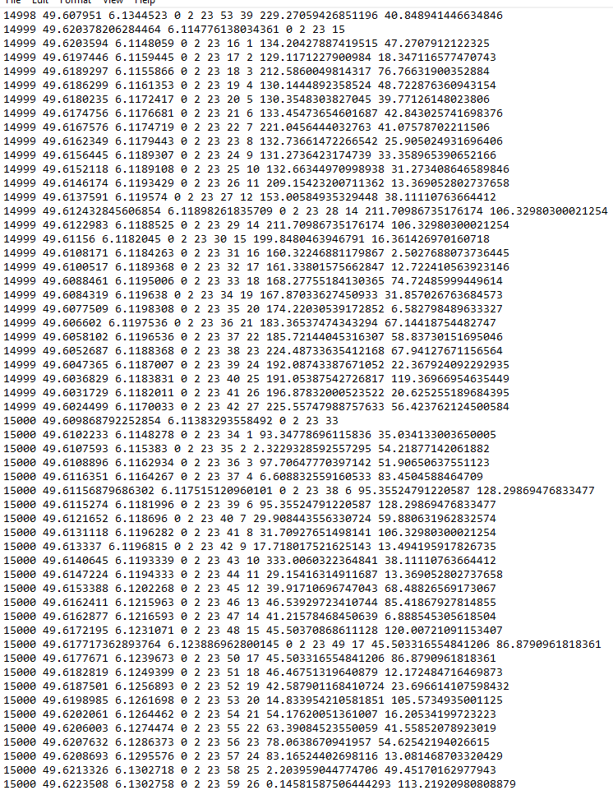

**Output of Crowdsensim2 model (after updating the main file) :**

* 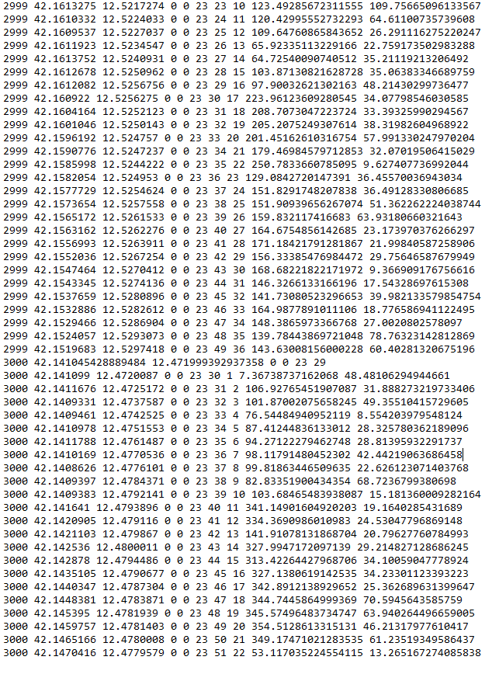UserMovementsListEvents_0.tx t
* UserMovementsListEvents_1.txt

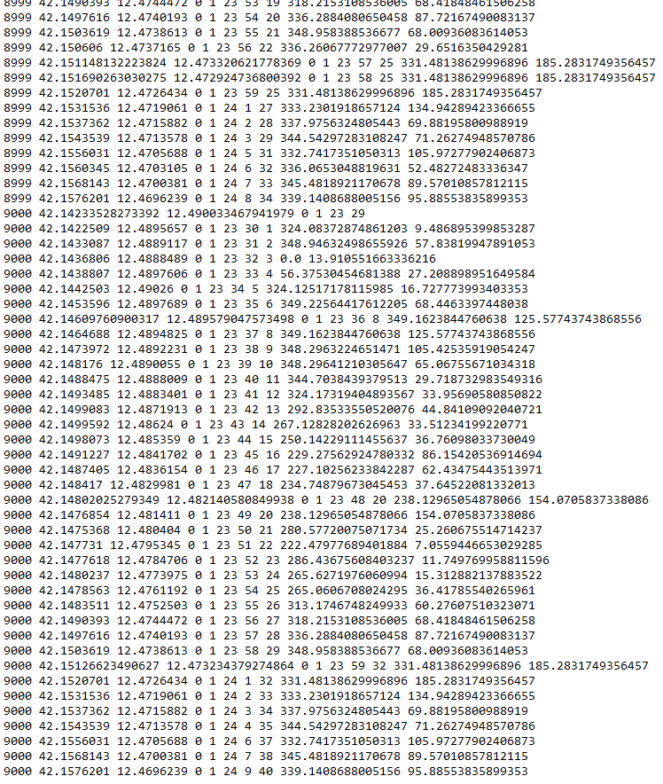

* 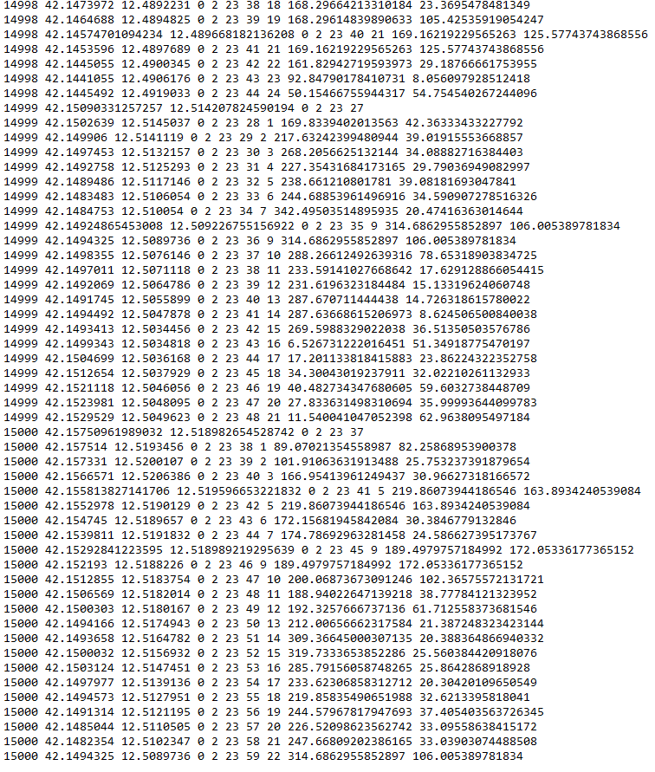 UserMovementsListEvents_2.txt